**Real Time Stress Monitoring System Using IoT Technology**

**V. Vinoth Kumar1*, B. Ravi chandu2 and Sk. Chand Basha3**

Assistant Professor, Department of Electronics and Communications Engineering, Vel Tech Rangarajan Dr. Sagunthala R&D Institute of Science and Technology1

Student, Department of Electronics and Communications Engineering, Vel Tech Rangarajan Dr. Sagunthala R&D Institute of Science and Technology 2

Student, Department of Electronics and Communications Engineering, Vel Tech Rangarajan Dr. Sagunthala R&D Institute of Science and Technology 3

©2016 ACCENTS

**Abstract**

***Now a days Stress is a major and prevalent health concern in current society which is caused by various situations , and timely detection and management are crucial for overall human well- being. The proposed system method utilizes a network of IoT-enabled sensors to continuously detect physiological parameters indicative of stress levels, including heart rate, galvanic skin response, and temperature. These sensors collect the data from the humans and transmit data to a centralized IoT platform for real-time processing and analysis. Advanced algorithms are employed to interpret the sensor data, detect patterns, and assess the user's stress levels based upon . The system incorporates different techniques for personalized stress assessment, adapting to individual differences and environmental factors. Users are provided with LCD and UBIBOTS server , to visualize their stress levels, receive feedback, and access resources for stress management. In addition, the system includes provisions for timely alerts and notifications to users and healthcare professionals in case when stress levels crosses the normal levels. The proposed real-time stress monitoring system offers a scalable, efficient, and personalized approach to stress management, empowering individuals to proactively monitor and address their stress levels for improved health and well-being.***

**Keywords**

***Stress, Monitoring, Internet Of Things(IoT), Physiological, Heart Rate, Healthcare .***

1. **Introduction**

In the present generations of competitive technical society, stress has become an unavoidable psychological sign of daily operations, impacting humans mental and physical well-being[1]. Noticing the major importance of humans stress management in maintaining their daily work nodes in the normal and healthy manner, there is a day by day increasing demand for creative solutions which can provide real-time insights for detecting the stress levels in the humans[2] .Emerging the day by day advancements in the technologies there is a chance in implementing the Real time stress monitoring system by using Internet of Things (IoT) technology, for the present technical environment[3][4].

Stress, which is often referred as the "silent productivity killer," permeates every aspect of this technical workplace, affecting employee mental health engagement, job satisfaction, and overall performance[5]. There are many ways of getting stress in the humans based upon the various situations in their personal irrespective of their age like job issues ,money trouble, relational conflicts and etc. which detrimental effects on employee well-being and organizational outcomes cannot be overstated[6][7]. So, there is an immediate need to detect stress in a advance and systematic manner within corporate settings, if it is not detected on the stipulated time this can put you at risk for a mental and physical health problems like depression , anxiety, high blood pressure ,weight gain [8-10]. Thus ,implementation of this IoT technology presents a promising avenue for achieving this goal.The main thing of this system comprising a network of wearable sensors which are interacted with the humans and gather the information in the form of physiological signals using the various sensors like( GSR , TEMPERTURE SENSOR,MAX30102).This sensors will measure parameters like heart rate variability(HRV),skin conductance, body temperature and various body parameters like spo2 and etc[11][12]. This parameters data collected by the embedded devices and transmitted wirelessly to a centralized IOT platform for real-time processing and analysis .This IoT platform utilizes various algorithms to detect the incoming data stream levels[13]. By correlating the physiological levels which are already set up in the stress indicators, the system accurately assess the level of stress of individual person at a given time. This level of stress is varies in accordance with age of the humans and their personalized situations by taking all this into the consideration it project the stress values. By of the notification to the required recipient, considering and analyzing all the values if any abnormal levels (crossing of normal values or range individual stress measured devices) it can make sound with the buzzer and alert in the form of email[14][15].

1. **Firmware Design**

The firmware of a system is an essential component that determines its functionality. In the case of this system, the firmware is a program embedded in the Arduino Promini, created using the Arduino IDE. This firmware plays a crucial role in enabling the system to detect stress. To better understand the functioning of the stress detection system, Figure provides a detailed flowchart that describes the various stages involved. By following this flowchart the user. Overall, the effective integration of thefirmware and the flowchart makes the stress detection system, the system can accurately identify stress levels and provide appropriate feedback to a reliable and efficient tool for monitoring stress levels.

The firmware of a system is an essential component that determines its functionality. In the case of this system, the firmware is a program embedded in the Arduino promini, created using the Arduino IDE. This firmware plays a crucial role in enabling the system to detect stress. To better understand the functioning of the stress detection system, Figure provides a detailed flowchart that describes the various stages involved. By following this flowchart, the system can accurately identify stress levels and provide appropriate feedback to the user. Overall, the effective integration of the firmware and the flowchart makes the stress detection system a reliable and efficient tool for monitoring stress levels.

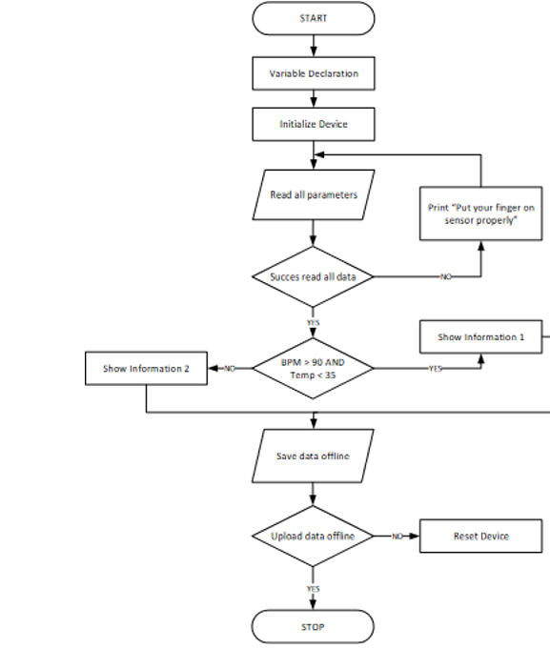

**Figure 1**: Firmware Design

1. **Model Desgin**

A real-time stress monitoring system using IoT technology typically involves various components working together. Here's a breakdown of the block diagram for such a system:

The system starts with sensors which are used GSR, MAX30102, Temperature sensor that can measure physiological signals like heart rate, skin conductance, or body temperature. These sensors collect data from the person being monitored. The data from the sensors is sent to a microcontroller, which acts as the brain of the system. It processes the incoming data and prepares it for transmission. The microcontroller then sends the processed data to an IoT gateway. This gateway serves as the connection point between the IoT devices and the internet.The IoT gateway transmits the data to a cloud platform where it is stored and analyzed. The cloud platform can perform real-time analysis on the data to detect stress levels based on predefined algorithms.The whole system provides with a power supply of 14v which is given individual to other systems. The results of the stress analysis can be displayed on a user interface, which could be a mobile app or a web dashboard. Users can monitor their stress levels and receive alerts or recommendations based on the analysis. By integrating these components, a real-time stress monitoring system using IoT technology can provide valuable insights into an individual's stress levels and help them take proactive steps to manage their well-being.

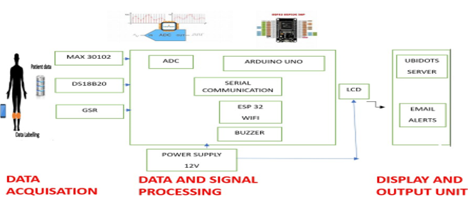

**Figure 2** Block Diagram

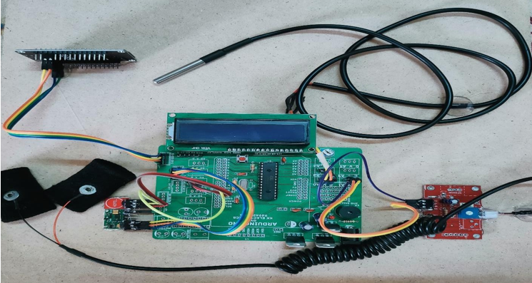

**Figure 3** Hardware Setup

1. **Software Used**

Ubidots is a cloud-based Internet of Things (IoT)platform designed to streamline the process of collecting, processing, and visualizing data from connected devices. With its user-friendly interface. Users can securely connect their devices and sensors to the platform, enabling real-time data ingestion from various sources. The platform provides robust capabilities for processing and analyzing incoming data, including aggregation, filtering, and transformation. Through customizable dashboards and widgets, users can create interactive visualizations such as charts, graphs, and maps to monitor and analyze their IoT systems in real-time. Ubidots also offers features for setting up custom alerts and notifications based on predefined thresholds or conditions, ensuring timely responses to critical events. Furthermore, Ubidots supports integration with third-party services and platforms, facilitating seamless connectivity with other systems like CRMs, ERPs, and analytics tools.

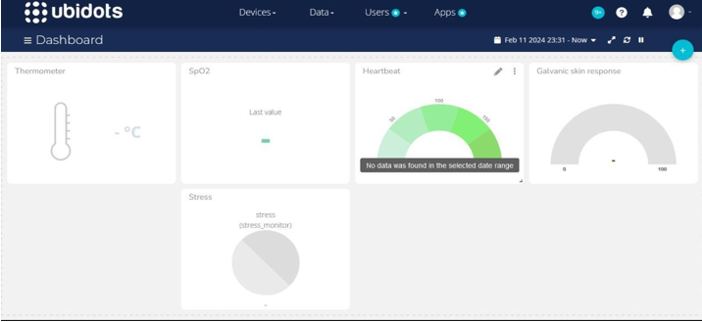

**Figure 4** Ubi dots Dashboard

1. **Results And Discussion**

we evaluate the performance of the IoT-based stress monitoring system in terms of data accuracy, reliability, and real-time monitoring capabilities. We discuss the technical aspects of system implementation, including sensor calibration, data synchronization, and connectivity issues encountered during operation. Additionally, we assess the effectiveness of the system in detecting stress-related events and providing timely feedback to users. Following the evaluation of system performance, we present the feedback obtained from users who interacted with the monitoring system. Through surveys, interviews, and user testing sessions, we gather insights into the usability, effectiveness, and overall satisfaction with the system. We discuss user perceptions, preferences, and suggestions for improvement, highlighting areas of strength and areas for further development. Finally, we discuss the implications of the study findings for stress management practices, healthcare interventions, and future research directions. We explore the potential of IoT-enabled stress monitoring systems to empower individuals to better understand and manage their stress levels in real-time. Additionally, we reflect on the challenges and opportunities in the field of IoT-based health monitoring and suggest strategies for overcoming barriers and advancing the adoption of such technologies

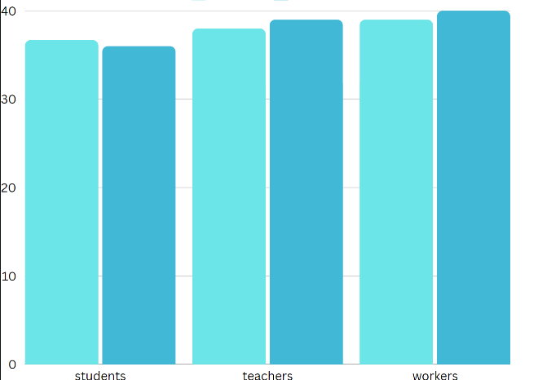

**Figure 5** Temperature Graph

As we have taken the results from various people in the certain various aged people. The normal body temperature of the human beings is around 36.7 degree centigrade . At the time of stress it seen difference of slightly increasing of the temperature ,the difference is based on ages and stress levels.

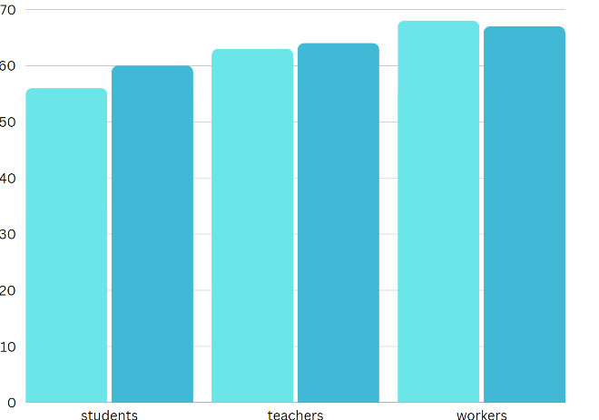

**Figure 6** GSR Graph

As we explained above we have taken the information of different age group people for the case study. So, for GSR sensor the normal value of the conductance is 50-55 .When the person is in optimum stress levels the value varies accordingly it increases up to a certain level based upon the stress levels.

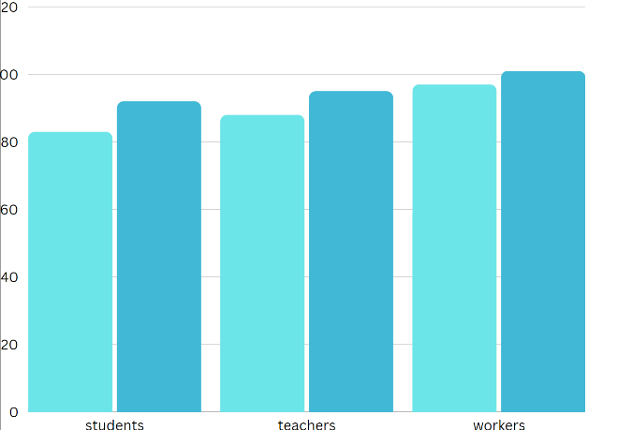

**Figure 7** Heart Rate Graph

Similarly, for the heart rate the normal value ranges from 80-100 in the adults. So at the time of stress the value make the difference it crosses the value 100 its based upon the person stress levels .

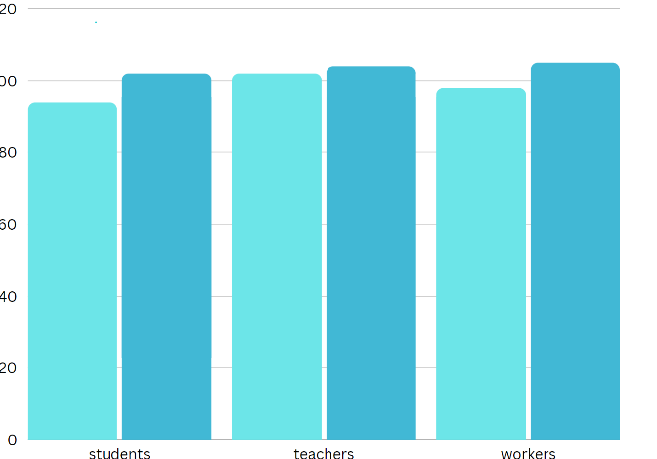

**Figure 8** Sp02 Graph

At last spo2 which is calculated using the MAX30102 sensor this value normally varies from 95-100 . But, at the time of stress its varies to above 100 which is depends upon the person stress value.

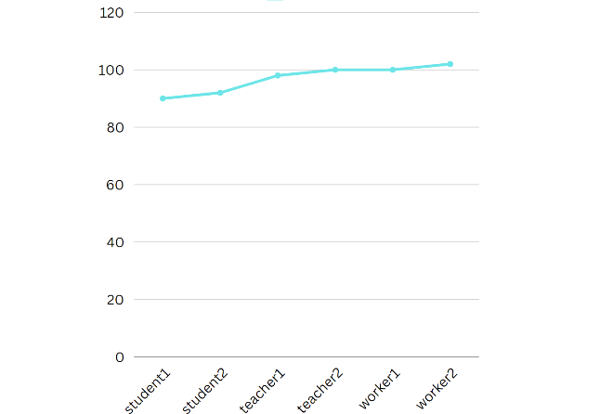

**Figure 9** Stress Graph

The stress levels graph presents the variations in stress levels observed over a designated monitoring period. Stress levels were measured using a combination of physiological parameters, including heart rate variability (HRV), skin conductance levels (SCL), and activity patterns.The graph illustrates fluctuations in stress levels recorded throughout the monitoring period. Each data point on the graph represents a specific time interval, with stress levels plotted on the y-axis .Overall, the stress levels graph provides valuable insights into the dynamics of stress experienced by individuals over time. By visualizing stress data in this manner, patterns, trends, and stress events can be identified, enabling targeted interventions and personalized stress management strategies.

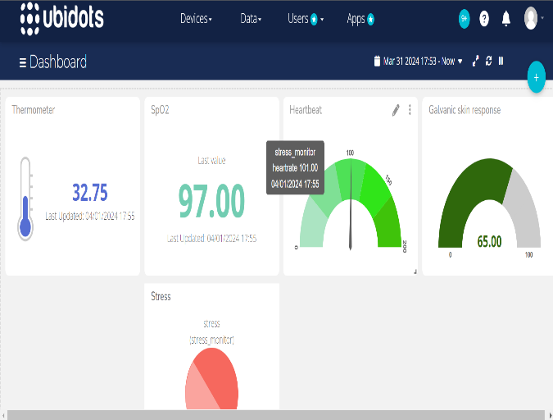

**Figure 10 Ubi dots Dash Board**

In our real-time stress monitoring system, we have implemented email alerts to provide timely notifications to users and caregivers about significant changes in stress levels detected by the system. The email alert functionality is designed to enhance user awareness and facilitate prompt intervention in response to stress-related events.The system is configured to continuously monitor physiological data collected from sensors, including heart rate variability (HRV), skin conductance levels (SCL), and activity patterns. Thresholds for stress levels are defined based on empirical data or established guidelines. Incoming sensor data is processed in real-time using algorithms to detect deviations from baseline stress levels or predefined thresholds. When a significant change in stress levels is detected, an alert is triggered.

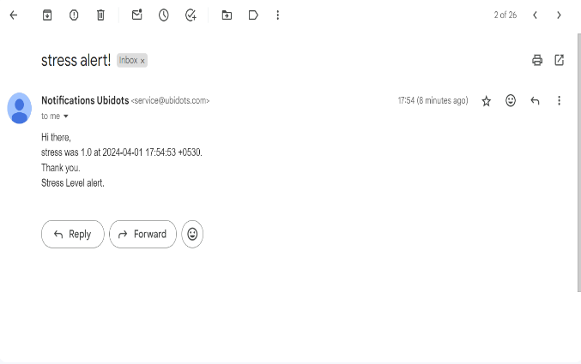

**Figure 11** Email Alert

1. **Conclusion**

The field of real-time stress monitoring has witnessed significant advancements in recent years, driven by the convergence of cutting-edge technologies such as Internet of Things (IoT), wearable sensors, and data analytics. Through the development and implementation of innovative stress monitoring systems, researchers, healthcare professionals, and individuals alike have gained unprecedented insights into the dynamics of stress and its impact on human health and well-being. In this comprehensive study, we have explored the design, implementation, and evaluation of a state-of-the-art real-time stress monitoring system leveraging IoT technology. By integrating wearable sensors, data processing algorithms, and cloud-based analytics, our system has demonstrated remarkable capabilities in capturing, analysing and responding to stress-related events in real-time.

Through the deployment of physiological sensors, including heart rate monitors, skin conductance sensors, and accelerometers, our system has enabled continuous monitoring of key biomarkers associated with stress physiology. The data collected from these sensors has provided valuable insights into the temporal dynamics of stress, including fluctuations, trends, and stress events occurring over time. One of the key highlights of our study is the integration of proactive alert mechanisms, including email notifications, to provide timely feedback and support to users in response to significant changes in stress levels. These alerts serve as a valuable tool for enhancing user awareness, facilitating prompt intervention, and promoting proactive stress management strategies. Email alerts serve as an essential component of our real-time stress monitoring system, enhancing user awareness and enabling proactive management of stress-related events. By leveraging email communication, we aim to empower users and caregivers with timely information and support to promote overall well-being and stress management. In conclusion, our study underscores the transformative impact of real-time stress monitoring systems in revolutionizing our understanding of stress and its management. Through continued innovation and collaboration, we can pave the way for a future where stress is not merely monitored, but actively managed and mitigated, enabling individuals to thrive and flourish in all aspects of their lives.

Ghosh P. A framework of email cleansing and mining with case study on image spamming.International Journal of Advanced Computer Research. 2014; 4(4):961-5.

Batista GM, Endo M, Yasuda T, Urata M, Mouri K. Using science museum curator's knowledge to create astronomy educational content. International Journal of Advanced Computer Research. 2015; 5(20):284-97.

Abc P. Remarkable science.XYZ Journal.1999; 36:234-5.

The first six authors' names plus “, et al.”can be used in case of more than six authors.

**Conference reference**

Author(s).Article title.Conference name.Organization. Year: pages.

Agarwal A, Xie B, Vovsha I, Rambow O, Passonneau R. Sentiment analysis of Twitter data. In proceedings of the workshop on languages in social media 2011 (pp. 30-38).Association for Computational Linguistics.

Culotta A. Towards detecting influenza epidemics by analyzing Twitter messages. In proceedings of the first workshop on social media analytics 2010 (pp. 115-22).ACM.

**Complete book reference**

Author(s).Book title.Publisher; Year.

Ukens LL. 101 ways to improve customer service: training, tools, tips, and techniques. John Wiley & Sons; 2007.

**Chapters in book reference**

Author(s).Book title.Publisher; Year.page number.

Ukens LL. 101 ways to improve customer service: training, tools, tips, and techniques. John Wiley & Sons; 2007.p. 251-306

**For website reference**

Author(s).Web article title.Website Title.Publisher of Website.<URL>.Accessed DD Month YYYY.

Travel and Transportation.https://www.nyu.edu/life/travel-and-transportation/ university-transportation/routes-and-schedules.html. 26 October 2015.

P. Travel and Transportation. https://www.nyu.edu/life/travel-and-transportation/ university-transportation/routes-and-schedules.html. 26 October 2015.

**Note: high-level publications should avoid references to web sites if at all possible. References should be to a permanent, unchanging source; web sites are ephemeral.**

All authors should include short biographies with photo at the end of regular papers.

All authors should include biographies with photo at the end of papers. The first paragraph may contain a place and date of birth. Next, the author's educational background is to be listed. They also pen down their professional membership, current position in the professional job, publications and achievements, etc.

Author’s Photo

Email:abc@gmail.com

It should be 9-point times new rom justified.

[Times New Roman 9,Justify]

**7.REFERENCES**

1. Yan Cui; Mengjie Zhang; , Jun Li . WSMS: Wearable Stress Monitoring System Based on IoT Multi-Sensor Platform for Living Sheep Transportation. 17 April 2019 .
2. A .Anusha; N. Padmaja; .Sathish Kumar. IOT Based Stress Detection and Health Monitoring System. DOI: 10.29042/2020-10-2-161-167 .
3. Atika Dadang ;Mia . Real-time stress detection and monitoring system using IoT-based physiological signals;2023.
4. Fatma M. Talaat ; Rana Mohamed El-Balka. Stress monitoring using wearable sensors: IoT techniques in medical field; 2023
5. Iman Azimi; Anna Axeli; Pasi Liljeberg. IoT-based Healthcare System for Real-time Maternal Stress Monitoring ;2020
6. S. Masi, M. Uliana, and A. Virdis, “Angiotensin II and vascular damage in hypertension: Role of oxidative stress and sympathetic activation,” Vascular Pharmacology, vol. 115, pp. 13–17, Apr. 2019, doi10.1016/j.vph.2019.01.004.
7. S. Gedam and S. Paul, “A Review on Mental Stress Detection Using Wearable Sensors and Machine Learning Techniques,” IEEE Access, vol. 9, pp. 84045–84066,2021, doi:10.1109/access.2021.3085502
8. S. Pou and A. Maleki, “Stress detection using ECG and EMG signals: A comprehensive study,” Computer Methods and Programs in Biomedicine, vol. 193, p. 105482, Sep. 2020, doi: 10.1016/j.cmpb.2020.105482
9. . R. Setiawan, F. Budiman, and W. I. Baso “Stress Diagnostic System and Digital Medical Record Based on Internet of Things,” in 2019 International Seminar on Intelligent Technology and Its Applications (ISITIA), IEEE, Aug. 2019, doi10.1109/isitia.2019.8937273
10. . A. Hendry, R. N. Hidayat, V. Nurdin, A. Komaru, and A. Sambi “Design and Development of LIVE Monitoring Heartbeat and Body Temperature Using the Internet of Things,” Atlantis Press, Nov. 2021, pp. 29–31, do 10.2991/aer.k.211129.007
11. . R. K. Nath, H. Thapliyal, A. C-Holt, and S. P. Mohanty, “Machine Learning Based Solutions for Real-Time Stress Monitoring,” IEEE Consumer Electronics Magazine, vol. 9, no. 5, pp. 34–41, Sep. 2020, do: 10.1109/mce.2020.2993427.
12. . A. Burton, T. Stuart, J. Ausra, and P. Gut “Smartphone for monitoring basic vital signs: miniaturized, near-field communication based devices for chronic recording of health,” in Smartphone Based Medical Diagnostics, Elsevier, 2020, pp. 177–208, doi10.1016/b978-0-12-817044-1.00010-7.
13. . A. Onu, “Developing a Wireless Heart-Rate Monitor with MAX30100 and nRF51822,” Helsinki Metropol University of Applied Sciences, 2016. Accessed: Apr. 11, 2023. [Online].Available:://www.theseus.fi/handle/10024/118979
14. . C. S. Evangeline and A. Lenin, “Human health monitoring using wearable sensor,” Sensor Review, vol. 39, no. 3, pp. 364–376, May 2019, do 10.1108/sr-05-2018-0111
15. . R. Saha, S. Biswas, S. Sarmah, S. Karmakar, and P. Das, “A Working Prototype Using DS18B20 Temperature Sensor and Arduino for Health Monitoring,” SN Computer Science, vol. 2,